NEDB2101 – Database Administration
Semester 1, 2024-2025
Course Coordinator: Dr. Murtaza Ali Khan
Lab 8 - Data Visualization using SQLite, Python and Google Colab
Objectives
- Load a database in Python Using sqlite
- Apply SQL queries to the database
- Read the table of database in panda’s dataframe
- Use functions of Python libraries such as panda, matplotlib, and seaborn for statistical analysis and visualization of the records in the table

Down the Database File
Download the database file from the following link and store in your local hard disk
https://drive.google.com/file/d/1nNNWb-2l09P8hwWZcUci3hWUzgCUt9Ve/view?usp=sharing

Upload the Database File in Google Colab
- Create a new notebook in the Colab
- On the left side menu click on the Files option
- Click on Upload to session storage icon
- Choose and TRADE_DB which you downloaded. It will be uploaded to the session storage
1 (Files) | 2 (Upload to session storage) | 3 (TRADE_DB)
 | 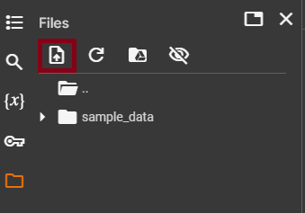 | 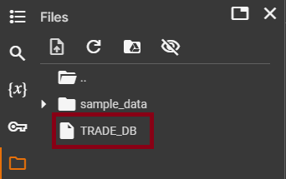

TRADE_DB
- It is the database
- The TRADE_DB is an existing database in the current working directory
- The TRADE_DB has a table called ITEM
- The TRADE table has following five fields (columns):
  - ItemCode
  - PurchaseDate
  - ItemName
  - ItemPrice
  - Category

Python libraries for data handling and visualization
Python has following libraries for data handling and visualization:
- Pandas (import pandas as pd): Used for data manipulation and analysis, particularly with DataFrames.
- Matplotlib (import matplotlib.pyplot as plt): A library for creating static and interactive visualizations.
- Seaborn (import seaborn as sns): Built on Matplotlib, it simplifies the creation of attractive statistical graphics.
- SQLite3 (import sqlite3): Allows interaction with SQLite databases for executing SQL commands and managing data.

Lab Task
- Open the new notebook in Colab and write the following code.
- Save your code with name Sqlite_Python_DataVisualization
- Run the code
We will discuss this code in the lab

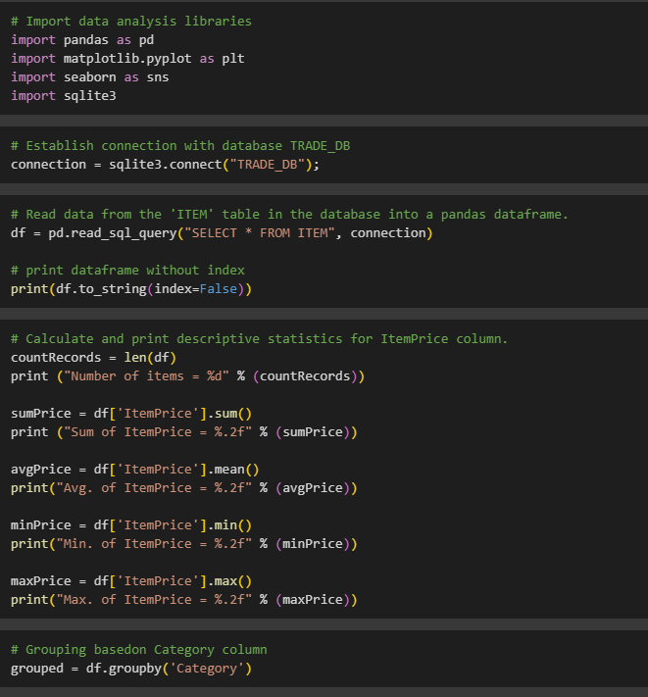

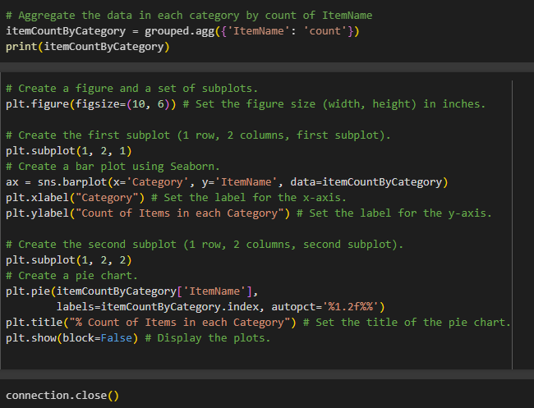
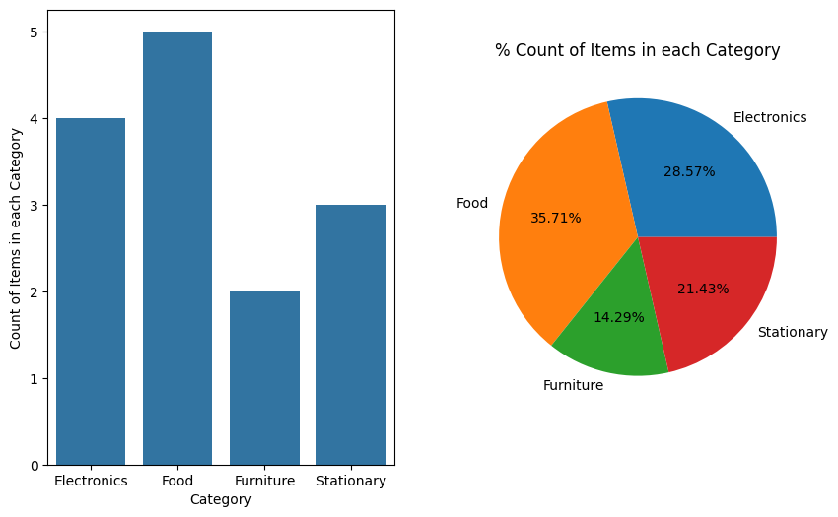
Loading, processing, and visualization of data in Python
- Import necessary libraries: pandas, matplotlib.pyplot, seaborn, and sqlite3 are imported for data analysis, visualization, and database interaction.
- Connect to the database: A connection is established to the SQLite database file named "TRADE_DB".
- Read data: Data from the 'ITEM' table in the database is read into a pandas DataFrame called df.
- Descriptive statistics: The code calculates and prints descriptive statistics (count, sum, average, minimum, maximum) for the 'ItemPrice' column of the DataFrame.
- Grouping by category: The DataFrame is grouped by the 'Category' column.
- Aggregation: The code counts the number of items in each category based on the 'ItemName' column and stores the results in a new DataFrame called itemCountByCategory.
- A bar plot is created to visualize the count of items in each category.
- A pie chart is created to show the percentage distribution of items across categories.
- Close connection: The connection to the database is closed.
Summary:
In essence, the code reads data from a database, performs basic data analysis, and then visualizes the distribution of items across different categories using a bar plot and a pie chart.

